Benefit Plan Detail template

Below is the Benefit Plan Detail template to use for all plans to submit to eTekhnos for your site build out. Reply to this email for each plan you need adding the plan name into the subject field above. Submit one at a time when you have the information required below together.

Client Name: TRICO Companies, LLC dba TRICO Companies
Plan Information: Buy-up LTD
Plan Name/Type: Buy-Up Long-Term Disability - All

Carrier Name: LifeMap
Carrier Website: www.lifemapco.com
Provider Network Web address: www.lifemapco.com
Carrier Phone #: 800.794.5390

Eligibility
Minimum weekly hours required for eligibility: 30 Hours
Wait Period: Eligible first day of calendar month following date of hire.

Contributions
Attached

Schedule:
Per Month

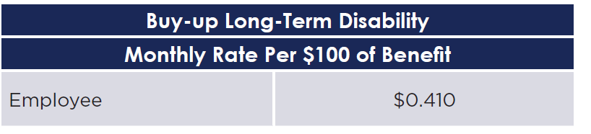

Forms
Please attach the Benefit summary, claim form, and enrollment form to have added to the plan. Also attach any additional forms you want listed: SPD, provider directory etc.
N.B. Please attach forms named as you would like them labeled in the site or indicate how you would like us to name each attachment.

eTekhnos
support@etekhnos.com
817-509-0004
www.etekhnos.com

